**CLOUD CALCULATOR**

**About Cloud Calculator:**

A Calculator that almost covers scientific operations. Input is similar to real scientific calculator instead each individual operations.

**How to Use:**

All inputs are default Degrees, if want to change just switch radio button to Radian or Gradient.

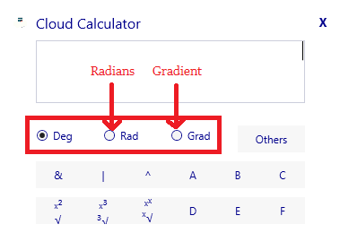

**Base Calculations:**

1. **AND (&):**

**It returns byte value like ‘1’ or ‘0’ by and logical calculation.**

**Input like 1 & 1 or 1 & 0 or 0 & 1 or 0 & 0. Not more than 1 or 0.**

1. **Or (|):**

**It returns byte value like ‘1’ or ‘0’ by and logical calculation.**

**Input like 1 | 1 or 1 | 0 or 0 | 1 or 0 | 0. Not more than 1 or 0.**

1. **Xor (^):**

**It returns byte value like ‘1’ or ‘0’ by and logical calculation.**

**Input like 1 & 1 or 1 & 0 or 0 & 1 or 0 & 0. Not more than 1 or 0.**

**Algebraic Calculation:**

1. **Square or Square Root:**

**Square Root can be done by √( 4 ) or √ ( 4,2 ).**

**Square can be done by 2**² **or Pow( 2,2 ).**

1. **Cube or Cubic Root:**

**It can be done by ³√( 4 ) or √ ( 4,3 ).**

**Square can be done by 2³** **or Pow( 2,3 ).**

1. **Higher Power or Root:**

**It can be done by √ ( 4,3 ).**

**Square can be done by Pow( 2,3 ).**

1. **Logarithm or anti-log:**

**Log: Log( 100,10 ) -> 100 = value; 10 = base ( base>1 ).**

**Base may be Exponential for natural log.**

**Anti-Log: Pow( 10,1 ) -> 1 = value; 10 = base of Log.**

1. **Natural Logarithms ( Ln ) or anti-log:**

**Log: Log( 100,Pow( e,1 ) )**

**Where 100 = value;**

**Pow( e,1 ) = base.**

**(Or) Ln( 100 ).**

**Anti-Log: Pow( e,1 ) -> 1 = value.**

1. **Percentage ( % ):**

**By Press % in Calculator or KeyBoard results ‘%’ Result.**

1. **L.C.M or H.C.F:**

**L.C.M with Single Value -> returns List of all Values behind entered Value.**

**L.C.M with Multi Values -> returns L.C.M of inputed numbers.**

**H.C.F -> returns H.C.F of inputed values.**

1. **Absolute Value:**

**Returns entered absolute value like (-1) -> 1.**

1. **Modulus:**

**Returns Modulus of two numbers.**

1. **Prime or List of prime:**

**Prime: returns true or false for given value.**

**List of prime: returns list up to entered value.**

**Input should be either Prime or List of Prime not more than that.**

1. **Inverse:**

**Returns Inverse value of given value.**

1. **Angle():**

**First enter value to screen and then press Angle**

**Input should be numbers only like 3, 4, 5 ….**

**Trigonometric Calculation:**

1. **Sin, Cos, Tan, Sinh, Cosh, Tanh:**

**Returns Sin, Cos, Tan, Sinh, Cosh, Tanh value for given value**

1. **Inverse Trigonometric Functions:**

**Returns ASin, ACos, ATan, ASinh, ACosh, ATanh value for given value**

1. **Pi:**

**Based on selected Mode ( Degree, Radians, Gradients ) returns Pi value**

**Permutations and Combination:**

1. **Permutation or Combination:**

**Returns Permutation or Combination of two numbers.**

**Input Like 5P4 or 5Co4 left side of ‘P’ or ‘Co’ should be higher than or equal to right side.**

1. **Factorial:**

**Returns factorial of inputed value.**

**Input Like 5!**

**Complex Numbers:**

1. **Polar Form ( r**∠ø):

**Convert from rectangular form (a+bi) to polar form**

**Input like Pol( 1,2 ) not more than this**

**1 -> r**

**2 ->** ø

1. **Rectangular Form (a+bi)**:

**Convert from polar form ( r**∠ø) **to rectangular form**

**Input like Rect( 1,2 ) not more than this**

**1 -> r**

**2 ->** ø

1. **a + ib or r**∠ø**:**

**Convert result from either polar to rectangular or rectangular to polar form**

1. **i or** ∠:

**For rectangular form input like a + bi.**

**For polar form input like r**∠ø.

**Matrices:**

1. **Add:**

**Add matrix by either Matrix A + Matrix B + …….**

**Or Add( Matrix A, Matrix B, Matrix C,…… )**

**Or Simply Add( 1, 2, …… ) simple numbers for algebraic addition.**

1. **Sub:**

**Sub matrix by either Matrix A - Matrix B - …….**

**Or Sub( Matrix A, Matrix B, Matrix C,…… )**

**Or Simply Sub( 1, 2, …… ) simple numbers for algebraic addition.**

1. **Mul:**

**Mul matrix by either Matrix A * Matrix B * …….**

**Or Mul( Matrix A, Matrix B, Matrix C,…… )**

**Or Simply Mul( 1, 2, …… ) simple numbers for algebraic addition.**

**Statistics:**

1. **Standard deviation, Variance, Mean, Mean Square, Sum of numbers or Sum of square of numbers:**

**Input just A or B or C or D or E or F only and press SD or variances or ….. keys.**

**Instructions:**

**Invalid Operations:**

**Single turn answer which are Pol( ) , Rect( ) , L.C.M( ) , Matrix, Prime( ) , ListofPrime( ) should input only those keywords only.**

**Base value like AND, OR,XOR should be either 1,0 or & | ^.**

**If input other than Mat or Statistics contains A, B, C, D, E, F it return zero.**

**Remember for using combination use nCor instead nCr.**

**Key press answers which are ‘=’, Angle(), SD, Variance, x̄, x̄², Σx, Σx², %, a+ib, r**∠ø**those returns direct answer only.**

**For providing input to statistics or matrices press ‘List of vaariable’ button in Calculator.**

**For other calculation like AP, GP, HP, Equation Solving, Constants and Conversions use Others button.**

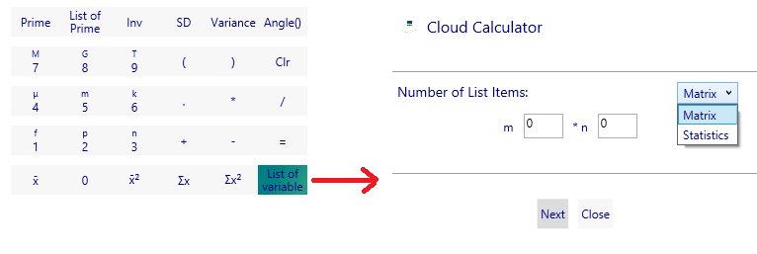

**Constants:**

**Select constant term in dropdown and provide input to get answer with its unit.**

**A.P:**

**Let 1 + 2 + 3 + …… + 10(Sum) or 1 – 2 +3 – 4 + 5 – 6 +……(sum and difference)**

**Here first number is 1, difference is 1(2-1 or 3-2 or 4-3 or …..) last number is 10.**

**Input using above terms.**

**By selecting Sum or Sum and Difference in dropdown it results the output.**

**G.P:**

**Let 1 + 2 + 4 + …… + 10(Sum) or 1 – 2 +4 – 8 + 16 – 32 +……(sum and difference)**

**Here first number is 1, ratio is 2(2/1 or 4/2 or 8/4 or …..) last number is 10.**

**Input using above terms.**

**By selecting Sum or Sum and Difference in dropdown it results the output.**

**H.P:**

**Let 1 + (1/2) + (1/3) + …… + (1/10) (Sum) or 1 – (1/2) +(1/3) – (1/4) + (1/5) – (1/6) +……(sum and difference)**

**Here first number is 1, difference is 1(2-1 or 3-2 or 4-3 or …..)**

**i.e (1/(1/2) – 1/(1/1) or 1/(1/3) – 1/(1/2) ….)**

**last number is 10.**

**Input using above terms.**

**By selecting Sum or Sum and Difference in dropdown it results the output.**

**Two Equation or Three Equations:**

**Two Equ => (ax+by=c and dx+ey=f)**

**Three Equ => (a1x+a2y+a3z=a , b1x+b2y+b3z=b and c1x+c2y+c3z=c)**

**Output returns like (a,b) (c,d) (e,f)**

**i.e (a,b) -> a=real number and b=imaginary number**

**input may be complex number which are proving I by keyboard and** ∠ **in button provided aside ‘Equations:’ Label.**

**Conversions:**

**Based on selected dropdown it returns respective output related to input**

**Results:**

**Output may be Complex number or decimal for normal operations**

**If input may be matrix it returns “[Collections to view Expand]” to view result for this right click on text and click expand button**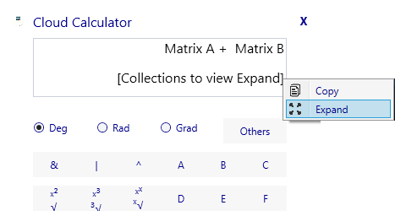

**--End of Page--**